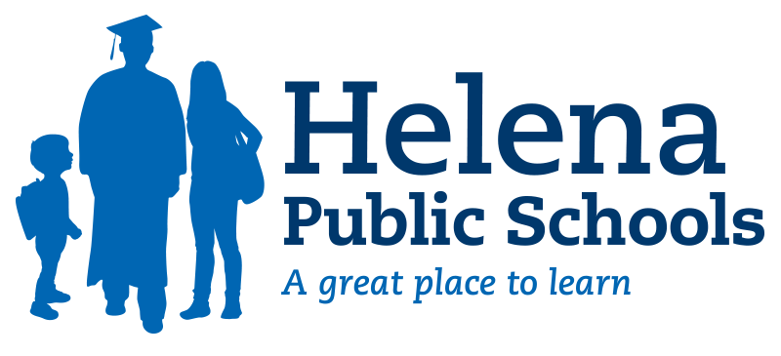

Plan for a Safe Return to In-Person Instruction and Continuity of Services
2022-2023 School Year

Updated January 2023

Purpose:
This plan is aligned with the 2021-2022 School Year Overview first posted by the Helena Public Schools on December 16, 2021 and subsequent scheduled updates. This Plan for a Safe Return to In-Person Instruction and Continuity of Services is supplemental in nature and aligned with state and/or federal requirements associated with Elementary and Secondary School Emergency Relief (ESSER) funding. While required for funding purposes, the below information is aligned with what our district has communicated through the above-noted overview. By design, the overview provides a narrative for the environment the district planned for fall 2021, and how plan components were implemented throughout the 2021/2022 school year and into fall 2022. As noted below, this plan, the aligned overview, and any other supplementary document/plan will be reviewed on a quarterly basis.

Scheduled Consideration:
- June 2021 (original date of post)
- December 2021
- June 2022
- December 2022
- June 2023

Part I: Pandemic Recap (March 2020 through December 2022)

Spring 2020: Helena Public Schools was ordered to close to in-person instruction on March 15, 2020, under an executive order issued by then-Governor Bullock. Districts were provided a two-week period of time during which they could remain fully closed to instruction of any kind while developing a plan for remote instruction required by the Governor.
Although our district was authorized to remain closed for a two-week period, Helena Public Schools quickly mobilized and began remote instruction within the week, on Thursday, March 19, 2020.

On April 22, 2020, then-Governor Bullock lifted the stay-at-home order, and announced a plan to initiate a phased reopening. As part of that plan, effective May 7, 2020, all schools were provided the option to return to in-classroom teaching at the discretion of local school boards. The Helena Public Schools utilized remote instruction through the remainder of the 2019-2020 school year, concluding school on Wednesday, June 10, 2020.
As our district worked through the initial weeks and months of the pandemic, the Board of Trustees considered and adopted various model policies provided by the Montana School Boards Association under its 1900 Series. These included policies aligned with CDC guidance regarding mitigation strategies to limit exposure to and transmission of COVID-19 in school settings.

Summer 2020: Across the spring and summer months of 2020, Helena Public Schools worked to develop a plan for the 2020-2021 school year. During that time, it became clear that the district would need a multifaceted plan to accommodate the anticipated rise and fall of COVID-19 cases in our schools and community. A public planning process was developed and detailed for the Board of Trustees as part of their June 9, 2020, meeting. A related update was provided to parents and families as the district’s planning strengthened to include volunteers from across our district and community.

Beginning in mid-June (2020), over 140 volunteers came together as part of eight teams to focus on the development of plans for each of the below-listed interrelated areas. These volunteers typically dedicated up to ten-plus hours per week to meeting and designing the plans contained within this overarching document. Their dedication and continual service to our students, families and community was invaluable to the iterative development of the best-possible plans.

Each team (figure 1) continued to meet through mid-July including dedicated feedback sessions with educators, parents, and other school partners. These “design sprints” (figure
2) provided early feedback from fellow stakeholders that successfully informed and shaped developing plans. Following each feedback session, teams utilized the shared insights to inform their designs.

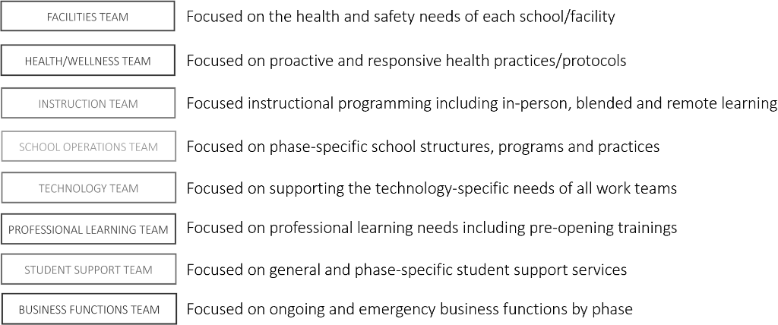
Figure 1: Planning Teams

Figure 2: Design Sprint Process Graphic
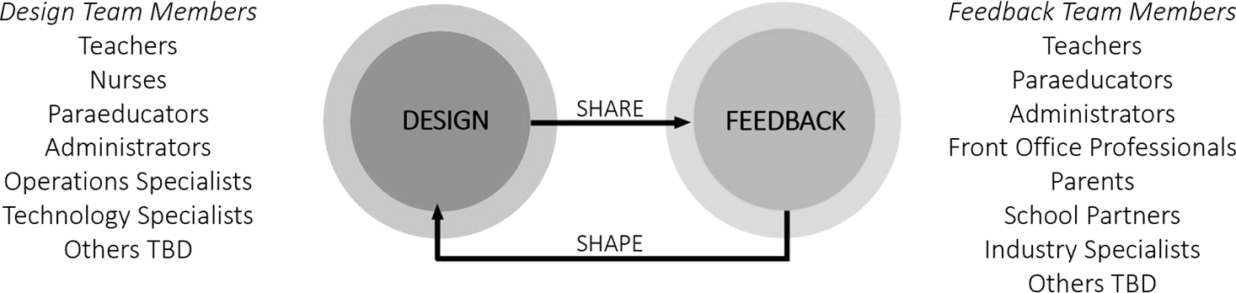

The district’s planning process included consideration of local, state, and national-level guidance. This guidance, along with regular feedback from our partners at Lewis & Clark Public Health, provided meaningful information that informed the various drafts of the 2020-2021 plan (link). The first draft of this plan was posted for public consideration in late July. Please see the associated link for parent/family updates that were associated with the pandemic (link).

2020/2021 School Year: Throughout the 2020-2021 school year, the district sought to provide quality learning opportunities to students, while maintaining safe, and healthy environments in alignment with national guidance from the Centers for Disease Control and Prevention (CDC). Helena Public Schools utilized three of the four outlined phases across the 2020-2021 school year. Phases included Phase 0 (remote only) for our two comprehensive high schools for a period of seven school days in late November/early December. Phase I (blended/hybrid) was utilized for all schools/grade levels across the fall semester and, depending on the level, into February and March 2021. Phase II (modified blended/in-person) was utilized for the remainder of the year. Phase III (normal format/operations) was not utilized at any point during the 2020-2021 school year.

Across the fall and winter, Helena Public Schools implemented designated phasing metrics to help inform school formal/phasing decisions. Metrics were updated weekly and communicated publicly as part of our Weekly Monitored Health Indicators reports). These phasing metrics were modified in February as a result of new guidance provided by the Harvard Global Health Institute.

As a school district, Helena Public Schools worked to update our community through the daily posting of COVID-related information, weekly reports, and other district-wide messages. The district held publicly noticed meetings, including opportunities for public comment. In addition, the district utilized data from multiple surveys to gain a better understanding of how our families and

employees were viewing matters pertaining to school within a pandemic. Feedback was carefully considered as our district worked to revise plans across the 2020-2021 school year.

Part II:

2021-2022 Plan Development (March 2021 through December 2022)
Helena Public Schools noticed, held, and invited public comment on our evolving plans for the 2021-2022 school year as part of the June Board of Trustees Meeting (June 8, 2021). This included the posting of the district’s overview document and an associated feedback survey. This was followed by a districtwide email on June 15, 2021, in which the plan was further highlighted and parents, families (including students), and HSD employees were encouraged to provide feedback.

Planning continued across the summer months, and the Helena Public Schools continued to post and communicate developing plans. In addition, the district worked to ensure that our efforts in this regard included a broad and diverse representation of our community, including families with special needs students; families with children learning English as a second/other language; families experiencing homelessness; children in foster care; migratory students; children who are in detention centers; and other families/students who may have had increased and/or unique needs.

A key focus was communication with families and staff, which began with our back-to-school welcome letter from the Superintendent on August 25, 2021, giving families an overview of the district’s COVID-response plan going into the 2021-2022 school year, including masking, online learning and close contact protocols. The letter was accompanied by an online COVID-19 Back-to-School Q&A. Communication continued throughout the 2021/2022 school year. Each Friday the Superintendent sent a district and community update, which, when applicable, included updates on the status of COVID-19 within the district and the district’s response measures. A total of 27 updates and notices regarding COVID were distributed to families and staff over the course of the 2021-22 school year. In addition, COVID positives for students and staff were posted daily to the district web site.

As the district continued to evaluate and address our practices, we developed and initiated family, staff, and student surveys, seeking feedback from internal and external stakeholders regarding their thoughts and experiences during the first semester of the 2021-2022 school year. This feedback was used to strengthen strategies and practices that were identified as positive and to revise and refine areas that were identified as perceived weaknesses. Links to the Panorama surveys were posted on December 6 and remained open until December 23, 2021.

By early December 2021, case numbers within the district had dropped significantly. Meanwhile, in late November 2021, vaccinations became available to children ages 5 to 11. The district helped staff and publicize vaccination clinics, which were held at East Helena High School and Bryant Elementary School on Nov. 13 and Nov. 20. and again at East Helena High School on January 15.

In mid-November 2021, the district also began offering free, drive-through COVID-19 test clinics to all household members of district students and staff at three school locations.

Based on these factors the district lifted the mask requirement, effective upon the district’s return from Winter Break on Jan. 4, 2022. This was announced December 10, 2021, along with the clear message that:

- In the event of a local spike or surge, and in consultation with local health care officials, the Superintendent would strongly consider a return to a mask requirement.

- With the exception of masking, the district’s other COVID-19 safety protocols would remain firmly in place, including social distancing when possible; a focus on cleaning; the use of outdoor space when possible; introducing fresh outside air into our learning spaces; the use of portable air filters; and regular cleaning and maintenance of air- handling systems.

Each school site had children-and adult-size surgical and cloth masks available free-of-charge, and families were reminded to keep students home if they were sick.

To prepare for a safe return to school on Jan. 4, 2022, the district’s school nurse team hosted a special drive-through testing clinic at the Lincoln Center (district central office) the evening of Jan. 3. The district continued to host free, evening drive-through COVID-19 test clinics at the Central Office in January.

On January 7, 2022, the district announced to parents that it was closely monitoring the arrival of the Omicron variant in our community and that a return to a mask requirement was a strong possibility.

On January 14, 2022, the district asked families and staff to voluntarily mask and reminded families to keep sick children home. In preparation for a local Omicron surge, the district appealed to parents and community members at this time to consider working as a para educator or substitute teacher to help keep schools open. At this time the district announced it was suspending evening drive-through COVID-19 test clinics due to supply shortages, but would continue to test students and staff who began showing symptoms during the school day.

On January 14, 2022, the district also announced that it would no longer conduct contact tracing due to the fast-moving nature of the Omicron variant, which reduced the relevance of tracing efforts.

On January 21, 2022, the district reinstated its mask mandate, as Omicron caused unprecedented growth in daily COVID cases as well as rising hospitalizations in the community.

On Feb. 11, 2022, the district announced that it would lift the K-12 mask requirement, effective Feb. 14, as case numbers and the number of hospitalizations in the community declined. Messaging once again emphasized that the district’s other COVID safety protocols remained firmly in place, including social distancing when possible; a focus on cleaning; the use of outdoor space when possible; introducing fresh outside air into our learning spaces; the use of portable air filters; and regular cleaning and maintenance of air-handling systems.

The district’s proactive measures to boost staffing and provide free testing clinics, coupled with COVD-prevention messaging and ongoing safety protocols, allowed Helena Public Schools to serve students with an uninterrupted 2021-22 school year.

On May 10, 2022, the Helena Public Schools Board of Trustees voted to rescind its 1900 Series Policies, which governed COVID-19-related response policies, as these policies are intended to be in effect only when a District Declaration of Emergency is in effect. The vote to rescind the 1900 Series Policies was taken in keeping with guidance from the Montana School Boards Association.

Also on May 10, 2022, Trustees adopted a new policy (Policy 7061 ), which is designed to address a wide range of public health emergencies, including COVID and/or other contagious diseases and pandemics.

In September 2022, the district conducted a safety and security audit led by Michigan-based Security Education Consultants (SEC). Among issues identified in the safety audit are the conflicting needs of bringing fresh air into older buildings by opening doors and windows – as was practiced when the district returned to a blend of remote and in-person learning in Phase 1 – and the need to keep doors and windows closed for building security.
The results of the safety audit will inform the district’s Master Facility Planning process, which is now underway. The resulting master plan will include communicable disease mitigation as a factor in design and planning of new facilities as well as maintenance of and enhancements to existing facilities.
The Master Facilities Planning process is now in its first phase, which included a November 1, 2022 visioning session with an ad hoc committee of parents, business leaders, educators, community leaders and other stakeholders. The ad hoc committee will guide outreach to the broader Helena community. The feedback gathered will include health and safety considerations, including facilities needs around COVID and other communicable diseases.

2022-23 School Year: One of the biggest COVID-related impacts the district anticipated for the beginning of the 2022-23 school year was the end of U.S. Department of Agriculture funding for free-of-charge lunch for all students.

Over the course of summer 2022, the district developed a robust communications plan to inform families that they would once again need to apply for the Free & Reduced Lunch Program to receive school meals free or at reduced cost.

Also in summer 2022, the district and the Helena Education Association (HEA) discussed the need to focus on culture and climate in the wake of the challenges staff experienced over the course of the 2020-2021 and 2021-2022 school years. The two entities launched a joint Climate and Culture Steering Committee to facilitate these efforts.

Under the steering committee’s guidance, the district and HEA held four half-day training sessions for leadership focused on Brene Brown’s “Dare to Lead” research. The sessions were attended by eight district-level administrators alongside eight HEA representatives.

This leadership training coincided with the launch of weekly listening tours throughout the district to get staff feedback on what’s working well and what’s not. The district is actively using this feedback to enhance its working and learning environments post-COVID. These listening sessions take place every Thursday at 8 am, rotating among each school in the district.

Meanwhile, to engage external stakeholders, district leadership is hosting monthly parent and teacher advisory meetings throughout the school year.

Collectively, these meetings with internal and external stakeholders are providing pivotal feedback, which the district is using to make both immediate and long-term changes to support our post-COVID learning and working environments.

Part III: Contents of The School District’s Plan for Safe Return to In- Person Instruction and Continuity of Services:
The below areas describe how Helena Public Schools will continue to maintain the health and safety of students, employees, and families.

Aligned Governance
Following the lifting of the Governor’s stay-at-home order and subsequent reopening of the state on April 22, 2020, Helena Public Schools utilized the Montana Public Education Center Roadmap for Safely Reopening Montana’s Public Schools Using Emergency School District Policies and as well as the MTSBA Model Emergency Policies listed below to determine next steps. The use of these resources supported our district’s continued service to students with transparency and accountability while ensuring the operations of the school district reflected the circumstances in our community.

Pandemic-Specific Policies: Dates of Original Adoption
  - Policy 1900: Adopted 03/27/20 – Revised 04/28/20, 05/12/20
  - Policy 1901: Adopted 03/27/20 – Revised 04/28/20
  - Policy 1902: Adopted 03/09/21
  - Policy 1904: Adopted 03/27/20 – Revised 04/28/20 – Terminated 06/08/21
  - Policy 1905: Adopted 03/09/21 – Revised 04/13/21, 06/08/21
  - Policy 1906: Adopted 04/28/20 – Revised 05/12/20
  - Policy 1907: Adopted 04/28/20
  - Policy Series 1900-1999: Rescinded 05/10/22

The policies ensured that our Board of Trustees and school leaders honored the following priorities:

- Continued teaching and learning for our students.
- A healthy, safe setting for students, employees, families, and the Helena community.
- Social-emotional supports for students, families, and employees. Responsible operational and fiscal procedures.

The policies provided an actionable plan for completing the 2020-2021 school year in a manner that met these priorities and secured district funding while providing an operational platform for considering long-term innovations in the delivery of education services. For additional policy-related information, please see the appendix.

Safety Measures
Helena Public Schools continues to actively consider the above-noted emergency policies, including any needed amendments, administrative procedures, and the suspension/removal of policies when they are no longer relevant or needed.

Furthermore, in an effort to ensure a safe and healthy environment for our students, employees, and families, Helena Public Schools has utilized specific plans and procedures, including;

- enhanced cleaning and disinfection
- revised guidelines for community use of facilities
- county board of health orders
- Covid diagnosis, testing, and confidentiality
- standard health protocols, including hand washing and related hygiene protocols
- provision of masks and personal protective equipment
- physical distancing
- symptom monitoring and isolation
- telework
- school closure orders
- stay at home orders
- travel quarantines
- restrictions for visitors, volunteers, and vulnerable individuals.

All decisions related to working conditions and health and safety are made in consultation with unions and employee groups. Health and safety initiatives and practices are overseen and coordinated by the District Safety Manager.

Universal and Correct Wearing of Masks
Helena Public Schools adopted and utilized a Board policy specifically related to the use of masks within/across our schools. In the 2020/2021 school year, masks were required for all students, employees, and visitors.

Board Policy 1905 was adopted on 03/09/21 in alignment with this ongoing expectation. The policy was revised on 04/13/2021 to allow masking outdoors to become optional.
On 06/08/2021, the policy was revised and renamed, and is now titled Student, Staff, and Community Health and Safety Needs.

Please note that Montana laws preclude policies/practices that include differentiated rules based on a person’s vaccine status. Therefore, the district must either require the use of masks for all students, employees, and visitors or choose to make masking optional. As of January 2022, the use of masks is optional.

Physical Distancing
During the 2020-2021 school year, classrooms were set up to maximize distancing in accordance with each utilized phase. Beginning in the latter half of the 2021-2022 school year and continuing into 2023, classroom arrangements are returning to formats that better allow students to engage in collaborative learning.

Handwashing and Respiratory Etiquette
Throughout the 2020/2021 school year, students became accustomed to new expectations with regards to handwashing and respiratory etiquette. Most notably, families were asked to symptom screen and keep children at home when they did not feel well and/or exhibited symptoms. Schools and classrooms worked to increase the access and frequency of handwashing and/or sanitization. The district continues to follow these practices, which include covering one’s face when sneezing or coughing and cleaning high-touch surfaces.

Cleaning and Maintaining Healthy Facilities (including improving ventilation)
Helena Public Schools will continue to ensure that its campuses and facilities are cleaned, maintained, and functioning with the health and safety of our students and employees as an ongoing priority. Air-handling systems within schools have been enhanced/upgraded to ensure needed air circulation and filtration. This includes no less than four (4) air exchanges per hour of clean air (fresh or purified) within each classroom and instructional space. Furthermore, the district continues enhanced cleaning efforts – practices that include proper sanitization of high-touch surfaces with a focus on handrails, doorknobs, light switches, etc. These health and safety protocols are coordinated and supervised by the district’s new Safety Manager whose position was added in November 2021. The position includes oversight of district air and water quality.

Contact Tracing
Through January 14, 2022, the district assessed each confirmed COVID-19 case for close contacts in cooperation with the Lewis & Clark County Health Department. This ended in January 2022, when the fast-spreading Omicron variant significantly reduced the practicality and efficacy of contact tracing.

School Nurses
School nurses continue to provide COVID-related health services, including, but not limited to, training on health and safety protocols for students and staff and assisting with staffing vaccination clinics.

The district will continue to employ one extra school nurse throughout the 2022/23 school year. This position is focused on COVID-related safety and care, as well as prevention of other respiratory illnesses that have caused a high rate of infection post-COVID.

Diagnostic and Screening Testing
In late fall 2021, Helena Public Schools initiated free-of-charge rapid testing for all students and staff within the district. Testing significantly supported staff and students, as the district was able to identify and respond to positive cases faster, reducing the amount of time COVID-positive individuals are in our facilities. As the district became more familiar with the testing process, free-of-charge rapid testing was expanded throughout the district for students, staff, and their immediate family members. Rapid-testing sites were opened in three school buildings and were later moved to a central location at the Lincoln Center to best meet the needs of our students and community.

While rapid testing clinics for employees and families have since been discontinued, COVID-19 testing is still performed when students or staff begin exhibiting symptoms during the school day.

Vaccinations
Helena Public Schools will continue to act in accordance with state and federal law with respect to vaccinations for its staff and eligible students.

In late November 2021, vaccination eligibility was established for children ages 5 to 11. The district has collaborated with Lewis and Clark Public Health, local health care providers including St. Peters Health, and the East Helena School District to provide vaccination clinics for those parents that want to participate and take advantage of vaccinations. A total of four clinics were held in November and December 2021.

The Lewis and Clark County Health Department also held a vaccination clinic at Central Elementary School in November 2022.

The district continues to share information regarding vaccination clinics and partners with local health care professionals to host vaccination opportunities as needed.

Please note that Helena Public Schools will not refuse, withhold from, or deny a person any services, goods, facilities, advantages, privileges, licensing, educational opportunities, health care access, or employment opportunities based on the person's vaccination status.

Accommodating Students with Disabilities
Helena Public Schools will continue to provide accommodations, aligned with related policies, for students with disabilities as determined appropriate based upon individual student needs and in accordance with individual accommodation plans or individualized education plans (IEPs). Students requiring accommodations should contact their IEP lead, their school’s administrator, or the Helena Public Schools Special Education Office to request information on plans for students with disabilities.

Continuity of Services
As part of the district’s planned teaching and learning environment, Helena Public Schools has prioritized the following services. Each is directly aligned to the needs of students, employees, and/or families.

Student Academic Needs
Central to the district’s priorities for the 2021-2022 and 2022-2023 school years was the assurance of a high-quality learning environment for all students and this focus continues in the 2022-2023 school year. The district’s teaching and learning environment evolved over the course of COVID-19 to include numerous practices associated with blended learning that were not previously common to our schools and classrooms. The district intends to continue to develop these beyond-the-classroom opportunities in an effort to enhance and interconnect both in-school and beyond-school learning. However, the district’s focus remains on keeping school doors open and classrooms staffed to provide students with the in-school, in person-learning that provides the optimal educational delivery and learning environment.

As a result of the pandemic, students experienced challenges and interruptions to their learning. This unfinished learning continues to be addressed through the district’s tiered intervention systems and practices. While academic interventions have always been a core part of the district’s educational delivery, a more robust set of academic interventions was implemented district-wide in the 2021-2022 school year to address the needs of students who are not performing according to grade level standards.
The district is taking a multi-pronged approach to identifying and closing pandemic-related learning gaps while enhancing instructional delivery for all.

Instructional coaches

At the heart of the district’s 2021-2022 initiatives to close learning gaps was the addition of 11 instructional coaches, for a total of 19. Learning coaches will continue their work throughout the 2022/23 school year and the district now has a coach in every school. Coaches support targeted instruction tailored to individual student needs and assist teachers with planning and curriculum development.

There are 12 instructional coaches assigned to PreK-5 schools; one for each middle school; and five for the high school level, including the Program for Alternative Learning (PAL). The new instructional coach positions were paid for through the federally funded Montana Comprehensive Literacy Plan Grant, federal Title I funds to support low-income students, and federal COVID relief funds.

Tutoring and Credit Recovery (high school and middle school)
  - Classes during school hours to support students with identified learning gaps in specific areas.
  - After-school credit recovery courses to help seniors complete coursework needed for graduation.
  - After-school tutoring continues in 2023.

WIN (What I Need)
Among the district’s new tools for academic interventions are daily WIN (What I Need) groups in which students work in small, staff-guided groups alongside peers with similar learning needs. WIN groups give students time to focus on specific concepts in math, reading, or other areas where they need extra support or, conversely, would benefit from enrichment activities. All elementary schools implemented WIN sessions on reading and math during the 2021-2022 school year, and WIN groups will continue throughout the 2022-2023 school year.

Camp Ascension Summer Academic Support (K-12)
K-12 students from across the school district attended the new Camp Ascension summer school programs in June, July, and August 2021. At the elementary level, students received targeted, individualized instruction, including structured reading routines, exploratory learning, and math lessons focused on foundational math skills and number sense. Afternoon field trips that correlated to the morning’s instruction helped the lessons “stick.”

At the middle school level, the camps focused on academic support for students with identified learning gaps in reading, math, and social skills. Students also participated in afternoon field studies using STEM activities to foster personalized learning. High school camps focused on credit recovery to complete coursework required for graduation.

In the summer of 2022, approximately 280 students from each elementary school participated in Camp Ascension, spending their mornings on reading and math and their afternoons exploring new horizons on field trips with community partners including the Stonetree Climbing Center, Exploration Works, and Farm in the Dell. At the middle school level, summer programs again focused on closing learning gaps as well as STEM activities (Science, Technology, Engineering and Math). High school courses were once again focused on credit recovery to complete coursework required for graduation.

Online learning opportunities High School and Middle School
In fall 2021, Helena Public Schools introduced the Edgenuity online learning platform to provide distance-and remote-learning courses for credit recovery or regular credit toward graduation requirements. This service is funded with federal COVID recovery dollars. Edgenuity is also used for remote learning by a small number of elementary students. At the high school level, the Montana Digital Academy offers distance/remote learning courses for credit recovery or original credit toward graduation requirements.

Student Academic Needs Conclusion
The above initiatives are producing measurable results. In reading, for example, the district’s second through fifth graders saw an average increase of 28% per grade level in the number of students meeting standards in benchmark testing between fall ’21 and spring ’22. In math, meanwhile, first through fifth graders saw an average increase of 46% per grade level in students who were proficient.
Gaps associated with unfinished learning will continue to be addressed, monitored, and remedied throughout the 2022-23 school year and beyond.
As illustrated in the graphic below, Helena Public Schools utilizes a multi-tiered system of academic and social/emotional supports ranging from all students (Tier I) to intensive, learner-specific needs (Tier III). This multi-tiered platform is embedded within our continuous improvement philosophy and practices, and, as expected, is dynamic and evolving.
Planned interventions include targeted summer opportunities for identified K-12 students focusing on both credit recovery and knowledge and/or skill/gaps (tier II).

Figure 3: HSD Multi-Tiered Systems of Support
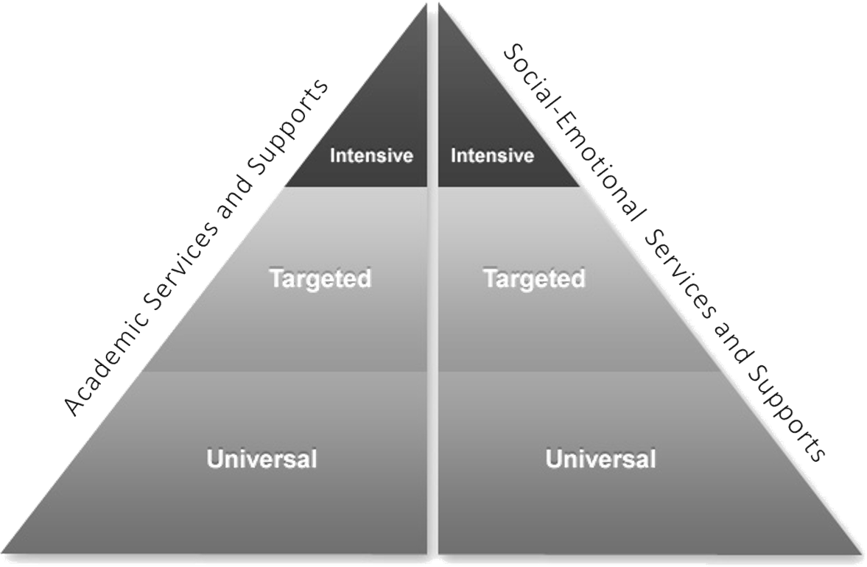

Student Social/Emotional and Mental Health Needs
The ongoing pandemic has produced well-documented social/emotional and mental health needs across our community, state, nation, and world. These needs, as they pertain specifically to school-age students, have been an ongoing area of analysis and collaborative effort. This focus on social-emotional needs remains an ongoing priority for the 2022-2023 school year.

Coupled with the district’s tiered academic interventions (above), this system of social-emotional supports utilizes a similar model to identify specific student needs and align targeted supports accordingly. As we move into a different, more normal phase of this pandemic, continued needs associated with the challenges and traumatic events of the past sixteen months are expected. School and district-based teams will continue to carefully monitor these needs to remain vigilant and align resources accordingly. These include interventions categorized in accordance with the three tiers outlined below, ranging from the “universal,” tier for all students to “intensive,” student-specific support services.

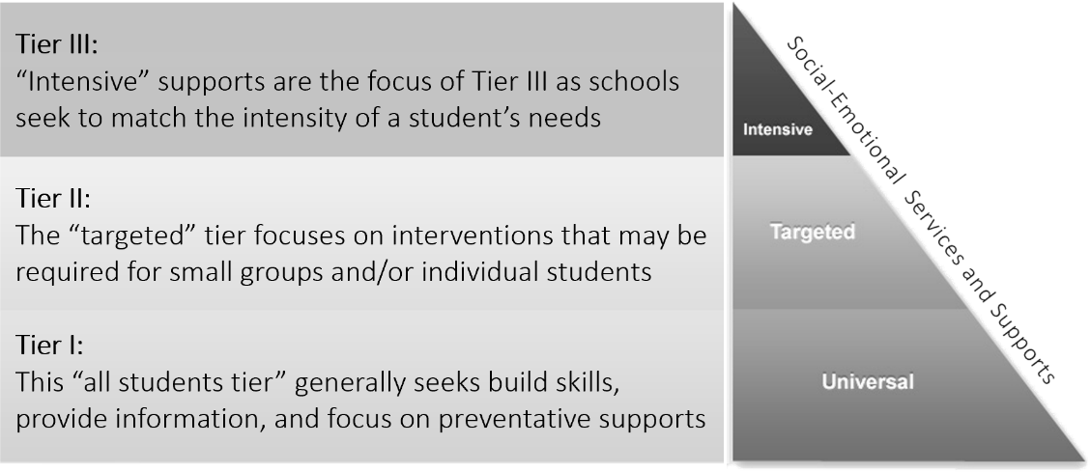
Figure 4: HSD Multi-Tiered Systems of Support

Other Student-Related Needs
The district returned to its standard operational format in most other areas at the start of the 2021-2022 school year, including start/end times, regular transportation schedules, normal classroom setups/environments, and other day-to-day aspects associated with our schools.
The exception was lunch and breakfast, which continued to be provided to families free of charge. Through the end of summer 2022, the district worked with its partner, Sodexo, to provide more than 2 million breakfasts and lunches to our community’s children – free of charge – with funding from the US Department of Agriculture.
That federal funding ended on the last day of the 2021-2022 school year and the district returned to its pre-pandemic meal policies in fall 2022. The district implemented a robust communications plan over the course of the summer to prepare families to resume paying for meals or to participate in the Free and Reduced Lunch Program.

Employee Social/Emotional and Mental Health Needs
Helena Public Schools continues to support the social/emotional and mental health needs of employees through access to licensed medical providers. These support systems include access to an Employee Assistance Program (EAP), a voluntary, work- based resource that offers confidential assessments and needed services including short-term counseling, referrals, and other follow-up resources for employees who need to engage personal and/or work-related problems.

The district will continue to provide access to the Lincoln Financial Employee Assistance Program and add supplemental programs throughout the 2021-2022 school year, including an employee wellness fair and wellness clinic with St. Peter’s Health in the fall and other activities to support employees.

Other Staff-Related Needs
Helena Public Schools continues to support of professionals through collaborative planning time, including Professional Learning Communities (PLCs). District staff participated in at least 100 training opportunities throughout summer 2022, spanning everything from conscious discipline to academic planning to school safety. This included the 2022 Montana Education and Literacy Institute, which was attended by approximately 70 instructional coaches, educators, and administrators through the district’s Montana Literacy Grant. The multi-day event offered sessions on K-12 leadership, instruction, literacy, and math strategies.

Public Input
Helena Public Schools posted/presented its draft plan for the 2021-2022 school year on June 8, 2021. The overview document was posted to the district’s website as an announcement/update and under the heading, “2021-2022 District Planning.” This ESSER required Plan for a Safe Return to In-Person Instruction and Continuity of Services has also been linked as a supplemental document.

The district actively sought public feedback on our developing plans including a survey and several updates sent to parents/families and Helena Public Schools employees.

The district is currently in the first phase of its Master Facilities Planning process, which included a November 1, 2022 visioning session with an ad hoc committee of parents, business leaders, educators, community leaders and other stakeholders. The ad hoc committee will guide outreach to the broader Helena community and the feedback gathered will include health and safety considerations, including facilities needs around COVID and other communicable diseases.

As noted above, the district will review this plan at least once every six months and will provide an opportunity for public input as part of this ongoing process. December 6, 2021, the district distributed a family, staff, and student survey. Feedback was used to help align our needs and focus on our strengths and perceived areas of growth.

Appendix

Aligned Governance/District Policies: Following the Roadmap for Safely Reopening Montana’s Public Schools Using Emergency School District Policies ensured the Helena Public Schools to remain in compliance with guidance and best practices provided by federal, state, or local health officials. Our schools and district have continued to adapt and adjust our policies as new and updated guidance and best practices have become available.

Furthermore, our format for considering these emergency-based policies provide us with opportunities to effectively consider input from our HSD Board of Trustees, administrative team, employees, parents, students, health officials, and Helena community. These policies have enabled us to adjust our procedures and practices during different phases in compliance with guidance and best practices provided by federal, state, and local agencies.

The Helena Public Schools will continue to follow the policies noted below while engaging in a quarterly reevaluation process to continue to ensure the health, safety and wellbeing of our students, teachers, staff, and community. These policies are expected to remain in effect for as long as needed throughout the pandemic and the associated period of recovery.

Topic | School District Policy  Reference | Description of Policy and Associated Website Link | Policy Adopted and Revised  Date(s)
Student, Staff and Community Health | 1905 | 1905: The Helena Public Schools adopted protocols as outlined in this policy, for the duration of the declared public health emergency. These protocols are designed to | 1. 03/09/21  2. 04/13/21  3. 06/08/21

and Safety Needs - Use of Face Masks |  | ensure the safe and healthy environment for both students and employees. As stated, the supervising teacher, principal, superintendent and/or designated personnel are authorized to implement these protocols in coordination with local and state health officials. The current version of this policy allows for masking to be recommended but  optional while indoors on school/districts grounds. | 4. | Rescinded 05/10/22
Student, Staff and Community Health and Safety Needs - Physical Distancing | 1905 | 1905: This policy establishes regulations regarding physical distancing by requiring, to the extent possible, all students, staff, volunteers, and visitors to maintain a three- foot distance between themselves and their colleagues and peers throughout the school day inside any school building, on school provided transportation, and on school property before and after school. Recess will continue as scheduled in accordance with recommended physical distancing guidance. Drop off and pick up of students will be completed in a manner that limits direct contact between parents and staff members and adheres to social distancing guidance around the exterior of the school  building while on school property. | 1. 03/09/21  2. 04/13/21  3. 06/08/21  4. Rescinded 05/10/22
Student, Staff and Community Health and Safety Needs - Handwashing and Respiratory Etiquette. | 1905 | 1905: This policy establishes the requirement for all students, staff, and others present in the school building to engage in appropriate hand hygiene. Hand hygiene includes but is not limited to washing hands with soap and water for at least 20 seconds. If hands are not visibly dirty, alcohol-based hand sanitizers with at least 60% alcohol  can be used if soap and water are not readily available. | 1. 03/09/21  2. 04/13/21  3. 06/08/21  4. Rescinded 05/10/22
Student, Staff and Community Health and Safety Needs - Cleaning and Maintaining Healthy  Facilities | 1905 | 1905: This policy establishes that district personnel will routinely clean surfaces and objects in any school building and on school property that are frequently touched. This process shall include cleaning objects/surfaces not ordinarily cleaned daily. | 1. 03/09/21  2. 04/13/21  3. 06/08/21  4. Rescinded 05/10/22
Student, Staff and | 1905; 3080 | 1905: This policy establishes that all students and staff | 1. | 03/09/21
Community Health |  | who are ill, feeling ill, diagnosed as ill, or otherwise | 2. | 04/13/21
and Safety Needs – |  | demonstrating symptoms of illness must not come to | 3. | 06/08/21
Symptoms of Illness |  | school or work. Students who have a fever or are | 4. | 1905
 |  | exhibiting other signs of illness must be isolated in a |  | Rescinded
 |  | designated area until such time as parents or caregiver may arrive at the school to retrieve the ill student. All |  | 05/10/22
 |  | surfaces and areas should be thoroughly cleaned and
 |  | disinfected once the student has vacated the area by staff
 |  | utilizing safety measures in accordance with state and/or
 |  | local health standards as applicable. Students may engage
 |  | in alternative delivery of education services during the
 |  | period of illness or be permitted to make up work.
 |  | To avoid exposing others to illness, parents or caregivers
 |  | who are ill must make arrangements with others to
 |  | transport students to school or events, if at all practicable.
 |  | If not practicable, parents, guardians or caregivers must
 |  | not leave their vehicle during pickup or drop off and must
 |  | arrange with District staff to supervise students in
 |  | accordance with physical distancing guidelines in this
 |  | Policy.
 |  | 3080: In all proceedings related to this policy, the Helena
 |  | Public Schools will respect and maintain a student’s right
 |  | to privacy. Although the district is required to provide

 |  | educational services to all school-age children who reside within its boundaries, it may deny attendance at school to any child diagnosed as having a communicable disease that could make a child’s attendance harmful to the welfare of other students. The Helena Public Schools will rely on advice of school nurses and the public health and medical communities in assessing the risk of transmission of various communicable diseases to determine how best to protect the health of both students and staff. The district will manage common communicable diseases in accordance with Montana Department of Public Health and Human Services guidelines and communicable diseases control rules. The district may temporarily exclude from school attendance a student who exhibits symptoms of a communicable disease that is readily transmitted in a school setting. The Helena Public Schools may notify parents of other children attending a school that their children have been exposed to a communicable  disease without identifying the particular student who has the disease. | 1. 03/20/12
Student, Staff and Community Health and Safety Needs - Diagnostic and screening testing. | 1905 | 1905: The School District has adopted the protocols outlined in this policy during the term of the declared public health emergency to ensure the safe and healthy delivery of education services provided to students on school property in accordance with Policy 1906, and a safe workplace when staff are present on school property in accordance with Policy 1909, and the safety, health and well-being of parents and community members. The school nurse(RN), principal, superintendent or designated personnel are authorized to implement the protocols in coordination with state and local health officials. The policy establishes regulations regarding symptoms of illness, and  temperature screening. | 1. 03/09/21  2. 04/13/21  3. 06/08/21  4. Rescinded 05/10/22
Vaccination Related Information | 3010 | Please note that House Bill 702 passed the 2021 Legislature and was signed into law effective May 14, 2021. New Section 1 of that law provides that it is an unlawful discriminatory practice for a governmental entity to refuse, withhold from, or deny to a person any local or state services, goods, facilities, advantages, privileges, licensing, educational opportunities, health care access, or employment opportunities based on the person's vaccination status. The law also provides it is unlawful for an employer to refuse employment to a person, to bar a person from employment, or to discriminate against a person in compensation or in a term, condition, or privilege of employment based on the person's vaccination status. Finally, House Bill 702 provides it is unlawful for a public accommodation to exclude, limit, segregate, refuse to serve, or otherwise discriminate against a person based on the person's vaccination status.  3010: Upon initial enrollment, an immunization status form shall be completed by the student’s parent or guardian.  The certificate shall be made a part of the student’s permanent record. A student who transfers from one school district to another may photocopy immunization records in the possession of the school of origin. The district shall accept the photocopy as evidence of  immunization. When a student enrolls in the Helena School | 1. 02.12.13  2. 10.08.13  3. 12.10.19

District the school the student left must send the original immunization records within thirty (30) days after the student has transferred out. Parents who choose not to immunize their child based on religious tenets must annually submit to the district a signed and notarized affidavit on the form prescribed by the State of Montana. The form must be presented to the district prior to the child’s first day of attendance. The statement must be maintained as part of the student's immunization records. The district will also accept medical exemptions as
required by law.
Coordination with State and local health officials. |  | 1900, 1905,  1907 |  | 1900: In light of the COVID-19 pandemic, the Helena Public Schools Board of Trustees found it necessary to adopt temporary policies related to emergency school closures, the ongoing provision of educational services to students, meetings of the Board, gatherings on school property, health and safety of students, staff and community members, human resource matters and/or other potential budgetary matters.  To ensure clarity and transparency, the Board has organized all emergency school policies into a temporary chapter. School District Policies Numbered 1900-1999 are intended to govern during any emergency related to COVID-19 declared by the President, Congress, Montana Legislature, Governor, Montana Department of Public Health and Human Services, County Health Department or the Board of Trustees.  1905: The Helena Public Schools adopted protocols as outlined in this policy, for the duration of the declared public health emergency. These protocols are designed to ensure the safe and healthy environment for both students and employees.  1907: The Helena Public Schools Board of Trustees is authorized to declare that a state of emergency exists within the community. A declaration issued by the Board of Trustees is distinct from any declaration in effect or previously issued by local, state or federal authorities.  Policy 7061: A "public health emergency"(PHE) is an occurrence or imminent threat of an illness or health condition caused by epidemic or pandemic disease, or a novel and infectious agent or a chemical or biological toxin, whose scale, timing, or unpredictability threatens to overwhelm routine capabilities. A public health emergency poses a substantial risk of significant human fatalities or incidence of permanent or long-term disability.  Such illness or health conditions also include, but are not limited to, illnesses or health conditions resulting from a local, state, national or global disaster. In the event of a declared public health  emergency as determined by the Board of Trustees |  | 1. 03/27/20  2. 04/28/20  3. 05/12/20  4. Rescinded 05/10/22  1. 03/09/21  2. 04/13/21  3. 06/08/21  4. Rescinded 05/10/22  1. 04/28/20  1. 05/10/22

or a public health service the Board authorizes the Superintendent to take appropriate action to protect the health and safety of all students, staff, and visitors to include but not limited to closure of school buildings, implementation of infection control measures, and other appropriate safety actions. The Superintendent will communicate with parents, citizens, and other stakeholders about the actions to be implemented per this policy.

Note: The Helena Public Schools will manage common communicable diseases in accordance with Montana Department of Public Health and Human Services guidelines and communicable diseases control rules. When information is received by a staff member or a volunteer that a student is afflicted with a serious communicable disease, the staff member or volunteer will promptly notify a school nurse or other responsible person designated by the Board to determine appropriate measures to be taken to protect student and staff health and safety. A school nurse or other responsible person designated by the Board, after consultation with and on advice of public health officials, will determine which additional staff members, if any, have need to know of the
affected student’s condition.
 | How the district will ensure continuity of services, including but not limited to services to address students' academic needs and students' and staff social, emotional, mental health, and other needs, which may include student health and food services. |  | 1906 |  | 1906: The Helena Public Schools adopted the protocols outlined in this policy to govern during the term of the declared public health emergency to ensure the delivery of education services to students onsite at the school, offsite at other locations using available resources including but not limited to online methods. The supervising teacher, principal, superintendent or designated personnel are authorized to implement this policy. The Board of Trustees may revise the school calendar to adjust the completion of the school year for particular grade levels and groups once students have satisfied the required number of applicable aggregate hours.  The Board of Trustees authorizes instruction of students at the school facility in a manner that satisfies the aggregate number of instructional hours outlined in the School District’s adopted or revised calendar for a school year affected by a public health emergency.  The Board of Trustees authorizes offsite (remote) and/or online instruction of students in a manner that satisfies the aggregate number of instructional hours outlined in the School District’s adopted or revised calendar for a school year affected by a public health emergency. Offsite and online delivery methods shall include a complete range of educational services offered by the School District and shall comply with the requirements of applicable statutes. Students completing course work through offsite (remote) and/or online instruction instructional setting shall be treated in and have their hours of instruction calculated in the same manner as students attending an onsite  institutional setting. |  | 1. 04/28/20  2. 05/12/20

The Board of Trustees authorizes proficiency-based practices including grading, graduation requirements, and/or the calculation of situations when a student demonstrates proficiency in a course area as determined by the Board of Trustees using district assessments consistent with District Policy 1902 and/or other measures approved by the Board of Trustees during the course of a school year affected by a public health emergency.

The Board of Trustees authorizes summer programing for the purpose of remediation of credit, maintenance of skills, and enrichment. All classes offered for credit must meet minimum state requirements for accreditation and may be delivered at the school or at another offsite location.
Remediation credit courses shall be offered, grades 9-12, in accordance with District advancement requirements. Credit course offerings must be approved by the Board of Trustees.

In accordance with Section 20-1-301, MCA, and any applicable collective bargaining agreement covering the employment of affected employees, the Board of Trustees may establish a school calendar with an earlier start date and a later end date from non-emergency school years to ensure students receive the minimum number of aggregate instructional hours.

Students shall receive services in accordance with the applicable Individualized Education Plan or Section 504 Plan based on methods and locations agreed upon and documented by the applicable team to meet the student’s needs and goals. Students shall have access to regular school counseling services whether their instruction is provided in an onsite, offsite or online setting. Staff shall promptly report any suspected student distress or concern to their supervisor for review and referral. Students receiving instruction in an offsite setting are governed by the staff obligation to report suspected child abuse or neglect. This policy in no way limits or adjusts the School District’s obligations to homeless students or students in foster care. Applicable District policies serving these
students, or this population of students remain in full effect.

